

**2020**

|  |
| --- |
| **FM Logo** |
| **Learning Management System with Automated Assessment** |
| **Team Members:**   * Karim Hisham Mansour * Anas Hassan Gouda * Martin Fawzy Shafik * Mohamed Essam Abdelaziz * Haitham Hashim Ezzat   **Project Supervisor:** Dr. Essam Eliwa |
| **Future Academy - Higher Future Institute for Specialized Technological Studies**  **School of Computer Science** |
| Project report submitted to Future Academy for the degree of  Bachelor of Computer Science  June 2020 |

**Team Members**

**Karim Hisham Mansour**

**Khm.karimhisham@gmail.com**

**+2 011 1739 1522**

**Anas hassan gouda**

**anashassan299@outlook.com**

**+2 010 2351 5929**

**martin fawzy shafik**

**Mf.martinfawzy@gmail.com**

**+2 012 2671 8898**

**mohamed essam abdelaziz**

**essam.lfc@gmail.com**

**+2 011 1826 1096**

**haitham hashim ezzat**

**Haitham.hashem.ezzat1997@gmail.com**

**+2 010 0471 8535**

**Acknowledgement**

**Abstract**

Nowadays the world is moving towards the automation and artificial intelligence in all institutions and organizations to facilitate their work and decrease the cost, in addition to getting the highest possible accuracy, So we have decided to build Future Marker which is a smart learning management system that can automatically marks and evaluates the programming assignments and MCQ exams, it also allow the instructors to share the course materials with the students.

Future Marker web application is one of the best solutions for the educational institutions specially the ones that are related to programming, it helps them to apply the distance education in magnificent way as the instructor can shares the materials, upload assignments, tests his students.

This project is trying to solve various problems such as saving time and efforts for instructors who spend much time on marking and evaluating the programming assignments and multiple choices exams manually, besides the final grade, many instructors do not have the opportunity to give every students a brief feedback for each one of them about their progress on

**Table of Contents**

Chapter1 Introduction and Background 1

Introduction 2

Problem definition 2

What is the importance of this problem? 3

What are the current solutions? 4

How will this solution solve the problem? What is new? 5

Scope 6

Summary 7

Chapter 2 Analysis and Design 8

Introduction 9

User Requirements: 9

System Requirements : 10

Functional requirements : 10

Non – functional requirements: 10

Stack holders 11

System Design 11

Availability 12

Block Diagram 12

Use Case Diagram 13

0hhoohhffffjjj 13

Class Diagram for first demo 14

Design Patterns 15

Sequence Diagrams 16

Database Design (ERD) 16

Used Technologies and tools : 18

Summary 18

Chapter 3 Deliverables and Evaluation 19

Introduction 20

User Manual 20

Testing 25

Quality assurance will consist of several stages: 25

Evaluation (User experiment) 25

First Experiment 25

Summary 27

Chapter 4 Discussion and Conclusion 29

Introduction 30

Main Findings 30

Why is this project important? 30

Practical Implementations 30

Future Recommendation 31

Conclusion Summary 32

References 33

**Table of Figures**

Figure 1: example for adding photos **Error! Bookmark not defined.**

Figure 2: software development life cycle **Error! Bookmark not defined.**

Figure 3 30

# Chapter1 Introduction and Background

**Main points**

* Introduction
* Problem definition
* What is the importance of this problem?
* What are the current solutions?
* How will this solution solve the problem? What is new?
* Project description
* Scope
* Methodology
* Deliverables
* Summary

## Introduction

Computer Science degrees are very popular study programs worldwide. A core topic in computer science is to learn programming skills. Programming is also related to several fields of technology, hence many university students -in various programs- study it. Novice programming students require to practice as much as possible to enhance their problem solving and programming skills. A key tool for instructors is setting assignment for students to encourage them to practice more. However, to gain the most required result from such assignments, quick and detailed feedback is required.

## Problem definition

The main problem with the traditional manual assignments marking is that the instructor usually need to spend a lot of time and efforts to check and mark every student's code and to write a report for every student on each assignment to give feedback for the submission that inform him that his submission was good enough or not, and advise students about the mistakes that they did and what points they have missed. Instructors also need to set a clear grading policy and give students a breakdown of the grading criteria (Gooblar, 2017). The time required to achieve this would usually mean late feedback delivery to students, it may take days and sometime weeks for a student to know his/her marks. furthermore, the accuracy of the marking or writing feedback may decrease as the number of students increase, in addition to that some students may plagiaries code from the internet or from their friends (Culwin F, 2001), and it is hard to check plagiarism for each student manually. In addition, student can submit the assignment only once, without being able to submit it again after the feedback he receives with his grade.

### What is the importance of this problem?

By 2020 all the Educational sectors are working hard to improve themselves by using new tools and technologies or improving the old ones (Khan, 2019), Today we can see the importance of following up with the students as fast as possible by monitoring their level, as the instructors can evaluate them by giving them assignment and marking them, but if we are going to talk about the coding and computing we have to admit that evaluating the students by the instructor is not easy and it requires more efforts and time to check the coding level and give them a feedback for every single task, hence providing instructors with easy to use automated code assessment tool that can evaluate assignment in no time with minimum setup, and giving instant feedback to student and send a report for the instructor about each student and what grade they take and what points they miss (Shashank Srikant, 2014), This will help student to enhance their programming skills vastly through learning from their mistakes, it will also enable instructors to set more assignments without the worry of the time they need to mark it. In addition, it will save a lot of time for the instructors and professors so that they can be more creative with their teaching with the students, furthermore now all universities and schools who don’t use or rely on an effective learning management system will suffer when any problem or epidemic happens because they will need to apply the distance education, and they can’t do this without a learning management system allow the instructors to communicate with their students and share the course materials with them, in addition to all institutions must have another alternative way to examine the students instead of the usual written exams, so they must prepare and get an online testing system so they can evaluate they students by online tests and quizzes on what they have studied from home, we can say that it becomes obvious that any educational institution are not willing to make progress in improving its distance learning mechanisms, won’t hold up in the future or when any crisis occur.

### What are the current solutions?

For many decades automatic assessment has been applied in many forms even before personal computers existed. Automatic assessment had already been suggested by Hollingsworth in 1960 (HOLLINGSWORTH, 1960).

In many programming courses at tertiary institutions the use of automated assessment has been proved useful through the use of systems like:

* The Course Master Automated Assessment System (2001) (Foxley, 2001)
* The BOSS Online Submission and Assessment System (2005) (Mike Joy, 2005)
* Individualized exercises for self-assessment of programming knowledge: An evaluation of Quiz PACK (2005) (Peter Brusilovsky, September 2005)
* ALOHA - A Grading Tool for Semi-Automatic Assessment of Mass Programming Courses (2006) (Tuukka Ahoniemi, February 2006)
* Easy Accept: a tool to easily create, run and drive development with automated acceptance tests (2006) (Jacques Philippe Sauvé, May 2006)
* PASS - Programming Assignment assessment System (2006) (Fu Lee Wang, August 2008)
* Automatic marking with Sakai (2008) (Suleman, 2008)
* Web-CAT: Automatically Grading Programming Assignments (2008) (Stephen H. Edwards, September 2008)
* Programming Task Packages: Peach Exchange Format (2008) (Verhoeff, 2008)
* PROGTEST: An Environment for the Submission and Evaluation of Programming Assignments based on Testing Activities (2011) (Draylson Micael de Souza, 2011)
* A System to Grade Computer Programming Skills using Machine Learning (2014) (Srikant, 2014)

**Course Master Automated Assessment System:**

This system is a desktop application that can mark several types of coursework in a non-trivial manner. That is, criteria can be set against which the work is thoroughly assessed. Specifically, the system is particularly good at marking computer programs in several languages including Java and C++. It can also mark diagrams and assist in the marking of essays. (refrence)

**Pros:**

* Marking several programming languages
* Marking diagrams and essays
* High effeciency

**Cons:**

### How will this solution solve the problem? What is new?

This project introduces Future Marker (Automated Task Assessment Cloud based System). It will reduce the effort and time consumed by instructors when they assess submitted tasks from students. It will assess tasks in one of two ways. The first one is by using logical technique which begin with compile the code to check for runtime errors, then evaluating typographic layout which is checking for the layout and indentation, besides the identifiers’ name and length and the written comments, then checking code efficiency by running multi dynamic test cases. The second one is by utilizing machine learning and natural language processing to make it even more easy to instructors to setup assignments.

Future Marker will solve many problems for students. It will allow students to submit assignments a number of times customized by the instructor to improve their grades and learn from their mistakes by getting instant feedback from the system. Future Marker will also check and report any plagiarized work through comparing submitted students’ assignments to each other. It will also compare submissions with previous years submissions for similar assignments and automatically search for and report similar solutions online.

Future Marker aims to utilize the recent technological advancement in both cloud computing and artificial intelligence to provide a smart, accessible, and easy to use system for programming instructors worldwide.

**Project Description**

Future Marker is an learning management system with an automated assessment for programming assignment, the system is goal is to allow the students and instructors to interact online together, future marker allow the instructors to upload materials and assignments for the students, the system marking the programming assignment and send a brief feedback with the marks for the student, you can access the system through the web app or mobile app (IOS & Android)

## Scope

The tools and languages used to develop the system are php, java, dart, Laravel,

The project aims to deliver a great online educational system that can evaluate the programming assignments and send the feedback to the students easily.

**Methodology (Proposed Approach)**

We will use agile methodology with incremental plan because it is easier to change the process to reflect changing customer requirements and the process works well when not all requirements are known.

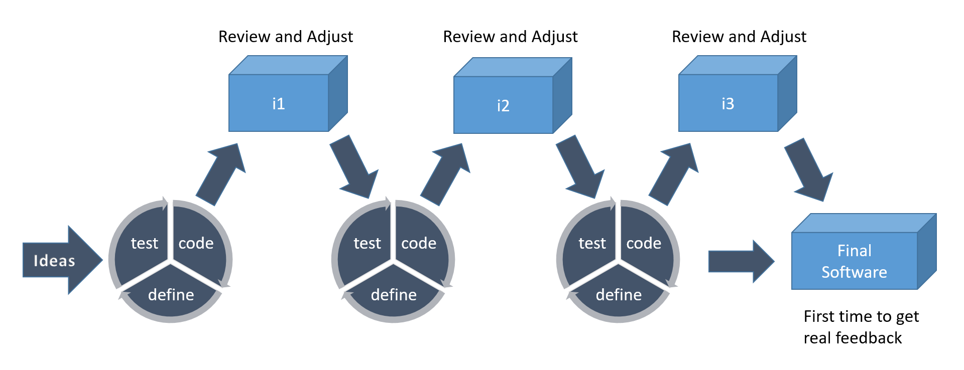

We will use scrum method because that focuses on managing iterative development, users see on-time delivery of increments and gain feedback that will help us to improve our system. We will have the flexibility to change anything while working on the system.

**Deliverables**

|  |  |
| --- | --- |
| **1** | **Project Proposal** |
| **2** | **Future Marker Demo Prototype (Desktop Application)** |
| **3** | **Future Marker Web application** |
| **4** | **Future Marker Mobile Application** |
| **5** | **Future Marker final Documentation** |

# **Summary**

In this chapter we have discussed the problem that we are going and to solve and how we are going to solve it and how important it is, also we have introduced our project and mentioned the project description and it’s functionalities and what methodology we are going to use in our work, in addition to listing some of similar examples that already exist and used to solve the same problem.

# Chapter 2 Analysis and Design

**Main points**

* Introduction
* User Requirements
* System Requirements
* Functional Requirements
* Non-Functional Requirements
* Stakeholders
* System Design

## 

## Introduction

In this phase we are planning to design our system after gathering information and checking the current solutions for our problem, we have designed the diagrams and divide the whole system into functions to start working on it besides writing the user stories in the Product Backlog as we are using scrum method while working Agile, Furthermore we chose our Git hosting service and Project management software that will help us in the implementation of the project and distributing tasks, Moreover we have picked our design pattern that we are going to use during our code implementation also we have made a comparison between different web application frameworks and decided which one is going to be more suitable for our system.

## User Requirements:

1- Future Marker shall allow the instructor the create course.

2- Future Marker shall allow the student to join the course.

3- Future Marker shall allow the instructor to upload material.

4- Future Marker shall allow the instructor to add assignment.

5- Future Marker shall allow the student to submit assignment.

6- The system shall automate feedback to the student.

## System Requirements :

### Functional requirements :

* Instructors shall create assignments and quizzes
* Students can submit assignments
* The system shall send automated feedback to students instantly
* Instructor can edit assignment grades
* The system creates report for instructors for each assignment
* The system assessments programming code by running multi test cases

### Non – functional requirements:

##### Security requirements:

-Future Marker not allowing the user to enter password less than 6 digits

-The system encrypts the passwords in the database

-The user must can’t sign in without registering on the system for one single time

##### Accessibility and Usability:

-Future Marker user interface is simple to use for any student or instructor at any age

-You can reach Future Marker from any device connected to the internet

##### Performance and scalability:

-The system functions work with high performance

- The system marks the tasks and send feedback in just 3 seconds

##### Portability:

-Future marker is web and mobile application

-Future Marker mobile app is cross-platform available for Android or IOS

## Stack holders

- Universities

- Instructors

- Students

## System Design

Future Marker is a 3-tier application architecture that consists of a presentation tier,

an application tier and a data tier.

* Presentation tier - This tier consists of web application and mobile application. The web application will be programmed using HTML5, cascading style sheets (CSS) and JavaScript. The mobile application will be programmed using flutter framework to provide mobile app for android and IOS
* Application tier - Contains the business logic of the system. It will be programmed using PHP, java and python, also it will be hosted on distributed servers in the cloud. Application tier communicates with the other tiers through application program interface (API) calls.
* Data tier – In this tier we will use Firebase as a database for the system because it’s a cloud-hosted NoSQL database that lets you store and sync between your users in real time.

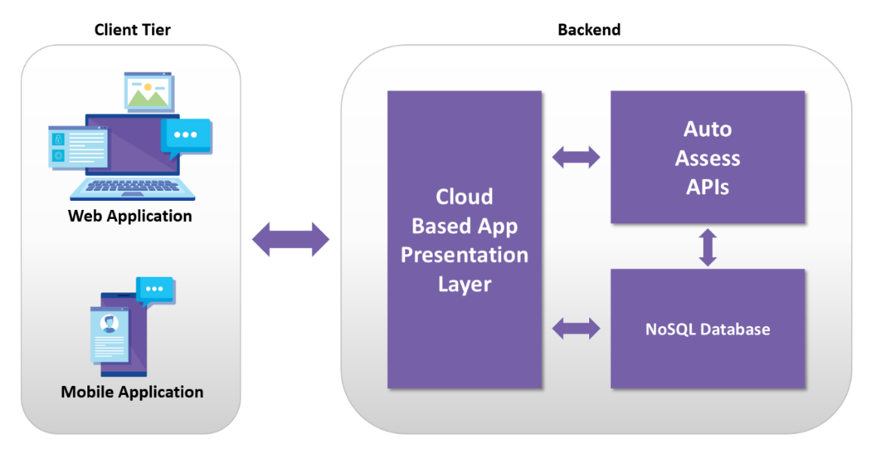

……………

Future Marker is consist of web application and mobile application the UI is developed by HTML, CSS, Java Script for the Web app, the mobile app developed by flutter, both of them access on the database which is built by MYSQL, and we are using Laravel(php platform) for the back-end tier

### Availability

Availability refers to a property of software that it is there and ready to carry out its task when you need it to be. This is a broad perspective and encompasses what is normally called reliability (although it may encompass additional considerations such as downtime due to periodic maintenance)

### Block Diagram

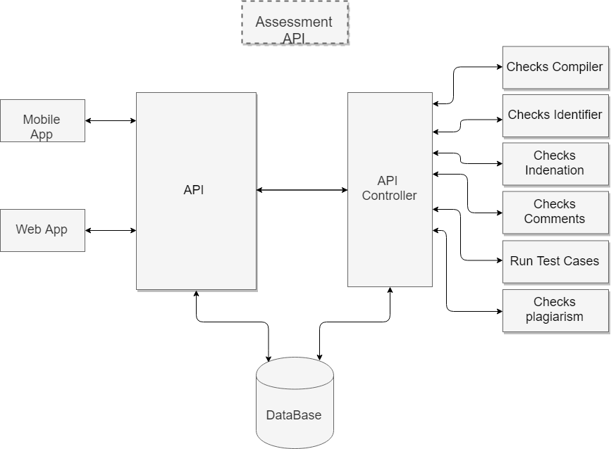

### Use Case Diagram

### 0hhoohhffffjjj

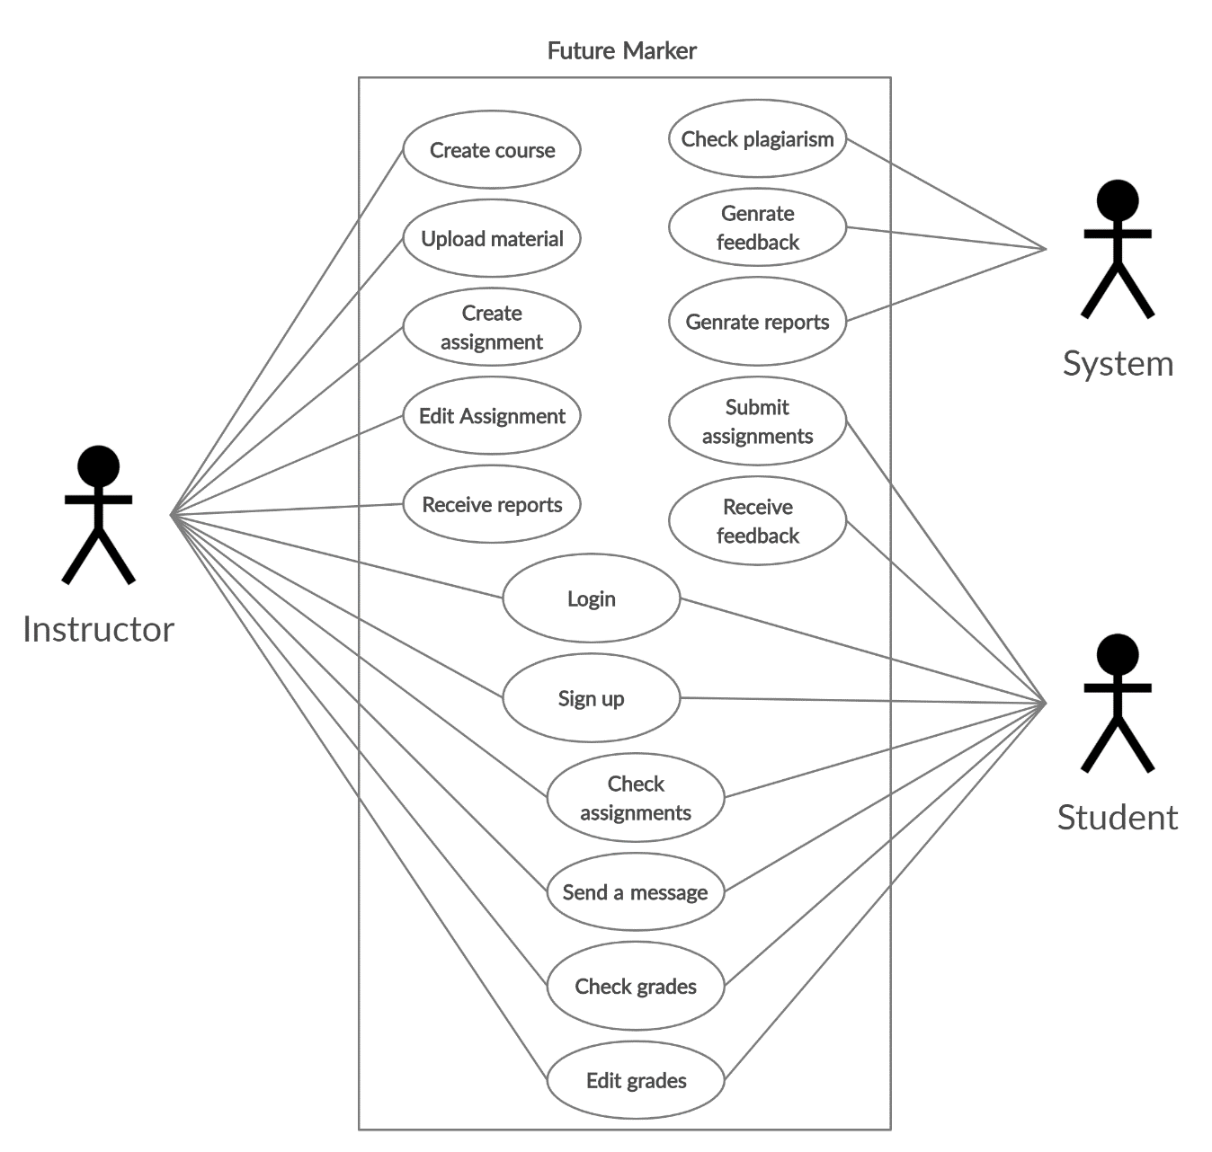

### Class Diagram for first demo

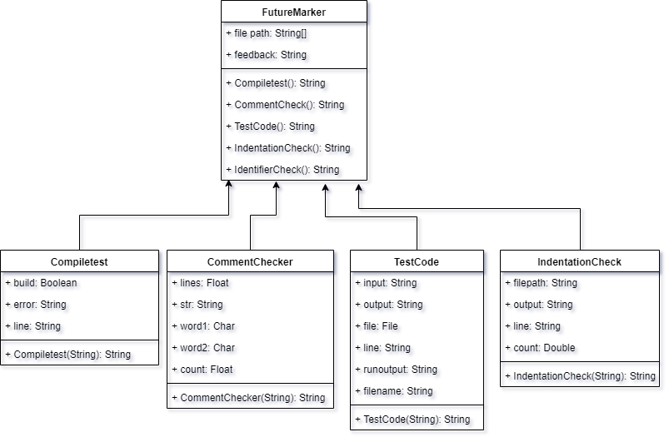

### Design Patterns

1. **MVC**

We are using MVC as a design pattern and we chose to work with Laravel because it is the most suitable platform that will help us using MVC.

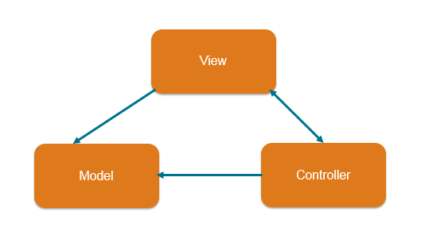

1. **Singleton**

The Singleton’s intent is to ensure that a class has only one instance. It implies that a Singleton instance should be reusable. The only way to keep a Singleton instance for future reuse is to store it in a static (or global) context. Existence of a static (or global) variable of a Singleton type is only a necessary condition. To identify a true Singleton, we must make sure there is no improper usage of a class, i.e. a new instance of a Singleton is instantiated only to initialize a static (or global) Singleton variable. As it might be hard to verify whether for each execution path an instance is assigned to a static variable, we propose only to verify whether such an execution path exists. (Tari, 2008)

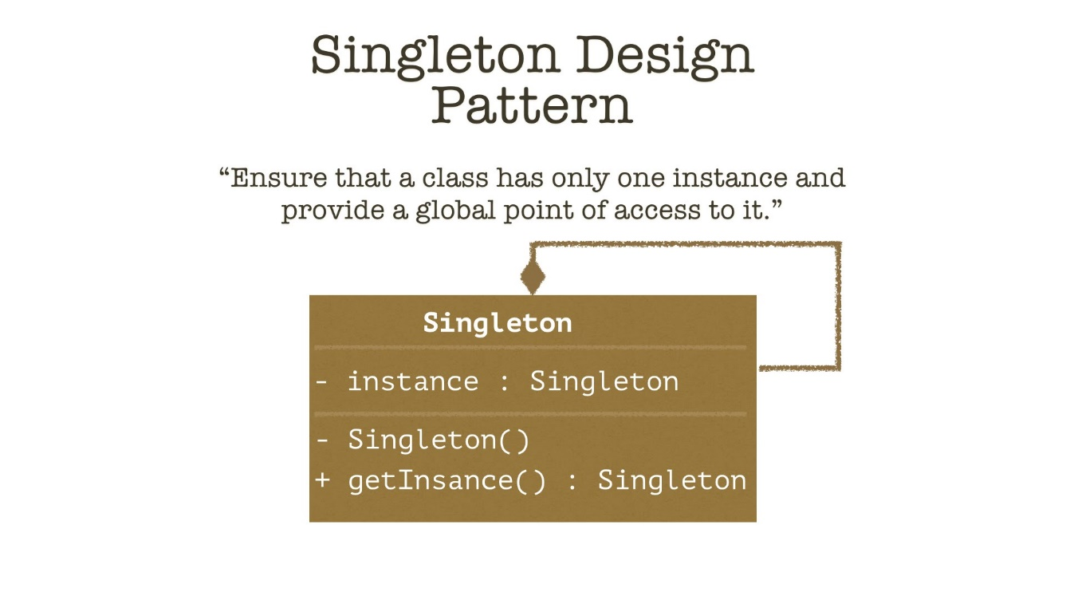

### Sequence Diagrams

Lorem ipsum dolor sit amet, consectetuer adipiscing elit.

### Database Design (ERD)

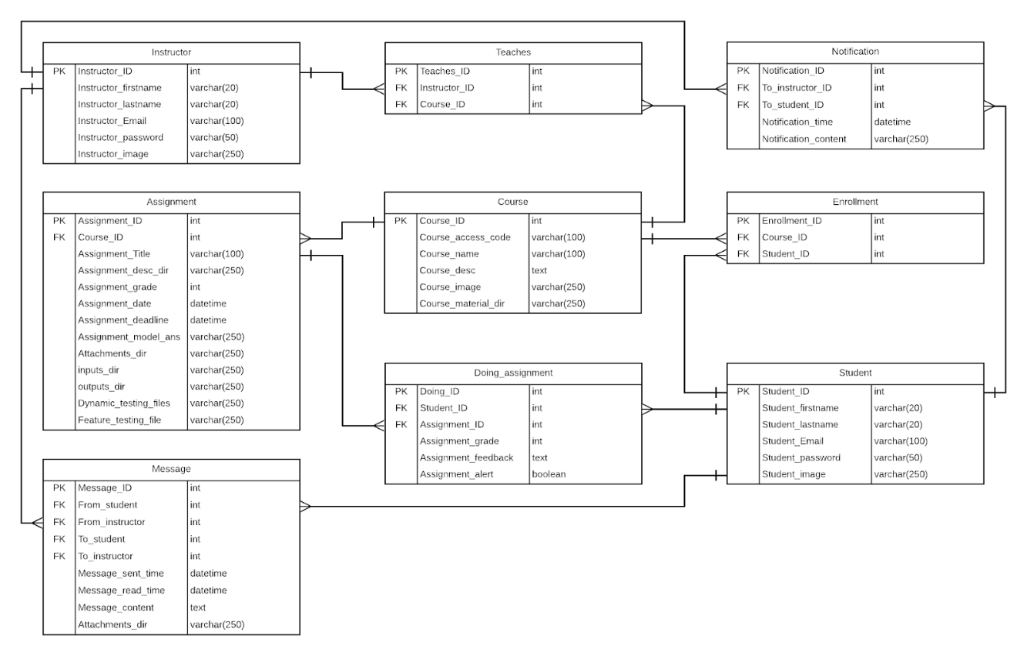

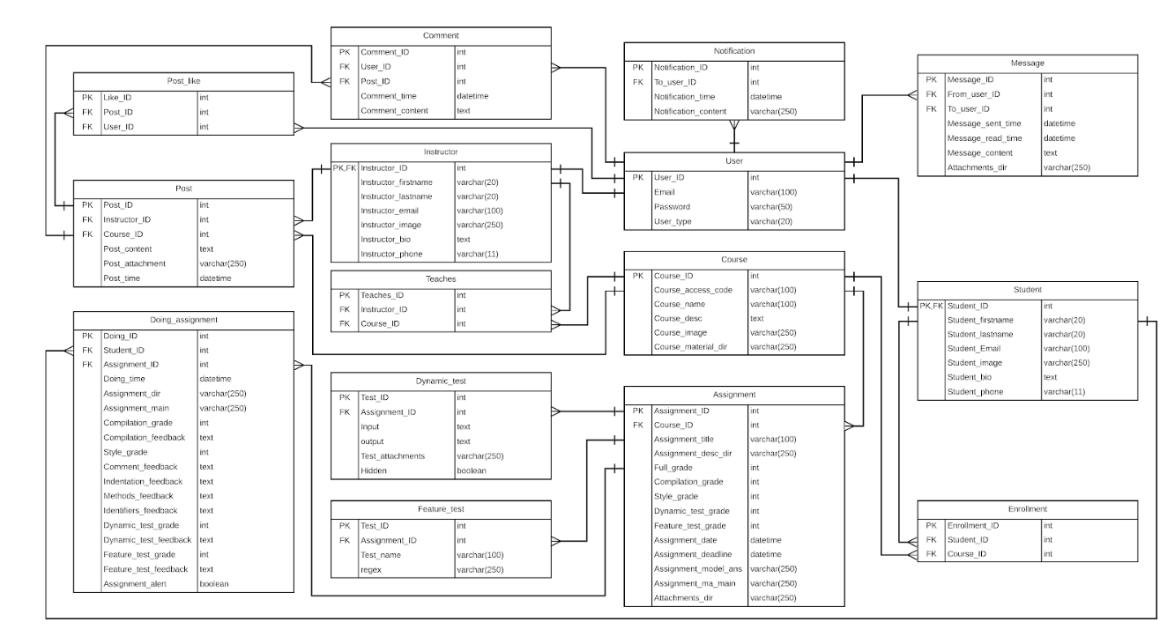

Storage Structure

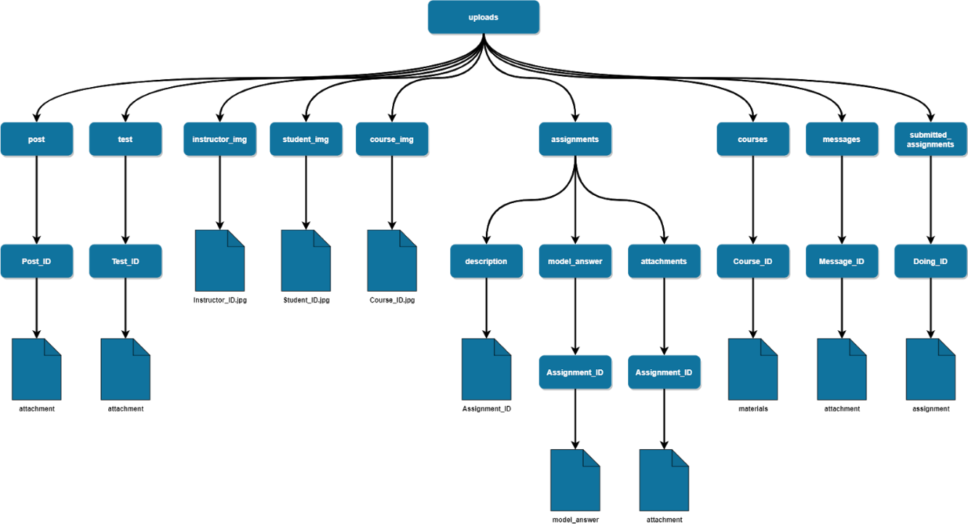

## Used Technologies and tools :

* HTML, CSS, Java Script
* Bootstrap 4
* PHP, MYSQL
* Laravel
* Flutter
* GitHub
* Jira

Summary

In this chapter we have discussed our analysis and design for the system, and the diagrams that describe it, we have discussed what tools and technologies we are using, furthermore,

we illustrated the functional and non-functional requirements, besides the user and system requirements.

# Chapter 3 Deliverables and Evaluation

**Main points**

* Introduction
* User Manual
* Testing
* Evaluation (User Experiment)
* Summary

## Introduction

In this phase we are showing the project deliverables and how we test our product, besides we are showing the user manual easily to the user so he can use the project and know how to use its features and specification without facing and any problems or constraints, Furthermore, we are representing the user experiment whether on the first demo of Future Marker or on the final output after finishing the product completely and discussing the result of this experiment and Feedback that we have received.

## User Manual

Here’s the user guide for helping you to access and use Future Marker

1. Open your Brower and go to futuremarker.com
2. Create an account by clicking on Register or Join us



1. Fill the registering details and choose whether you are signing up as a Student or Instructor

Note: Password should be not less than 7 digits

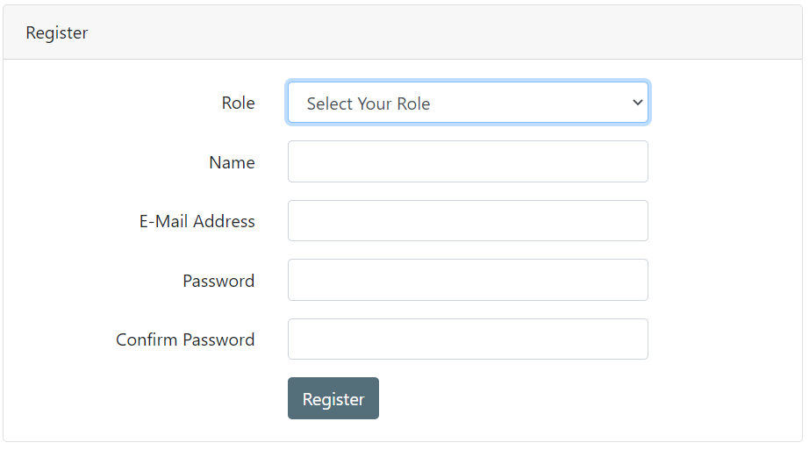

….

Instructor’s guide:

1. Welcome to the home page after signing in
2. Now you can a create new course by click on “Create New Course” button

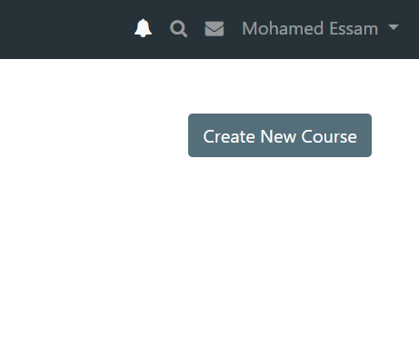

1. Now you have to fill the course details and press submit in order to create it

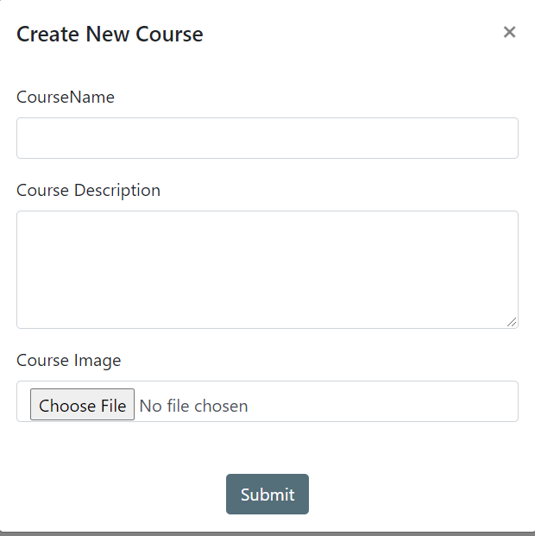

1. Now you have successfully created the course and you can take the Access Code to share it with your students

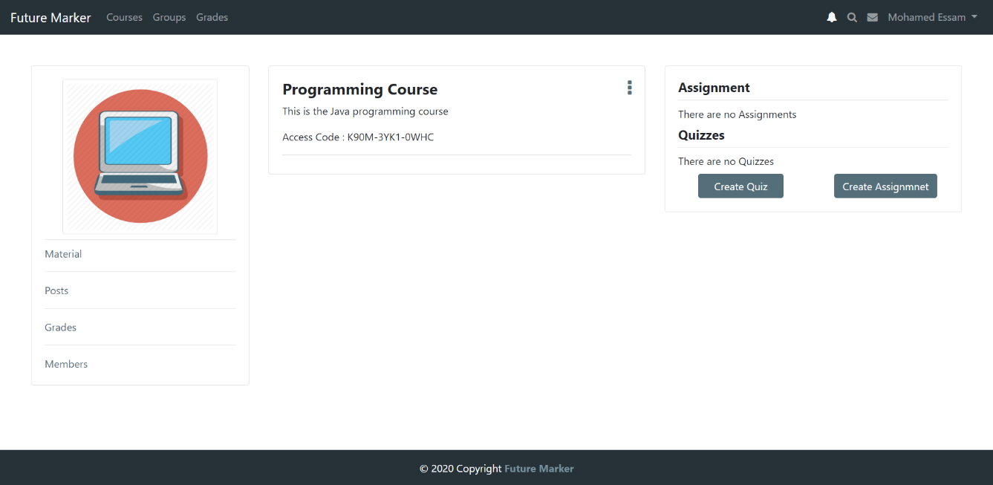

## Testing

## Quality assurance will consist of several stages:

* Review of requirements
* Test planning / writing test cases
* Unit testing
* Integration testing
* System testing
* Performance testing
* Security testing
* Cross-browser testing / cross-platform testing
* Updating test cases
* Regression testing

## Evaluation (User experiment)

## First Experiment

After finishing three main functions from our project which are checking comments in the code, Code indentation and identifiers name and length, we had decided that we have to test it with second year computer science students at Future Academy in a specific programming course which is CSC211 - Programming Language (2).

This experiment consisted of two submissions, after first submission we provide them with grade report showing them how the program evaluates their comments, indentation, identifiers, and after the students see their grade report for each java class, they try to modify and edit their code again for the second submission.

The following graphs shows the improvements in grades for some teams in each section (Comments, Indentation, and Identifiers) in the first and the second submission.

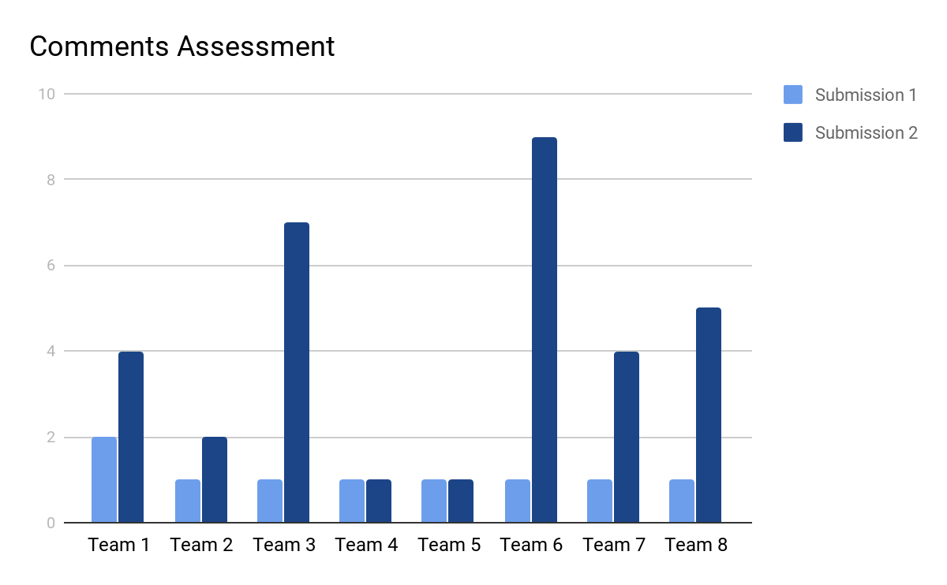

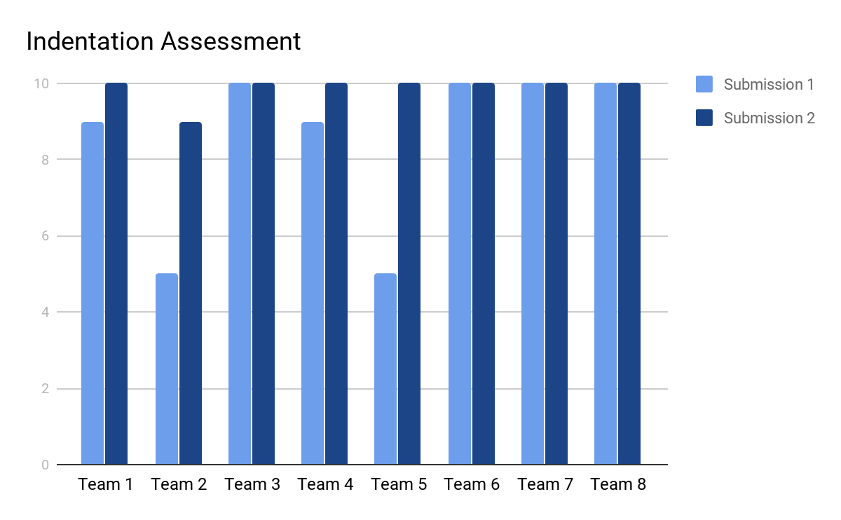

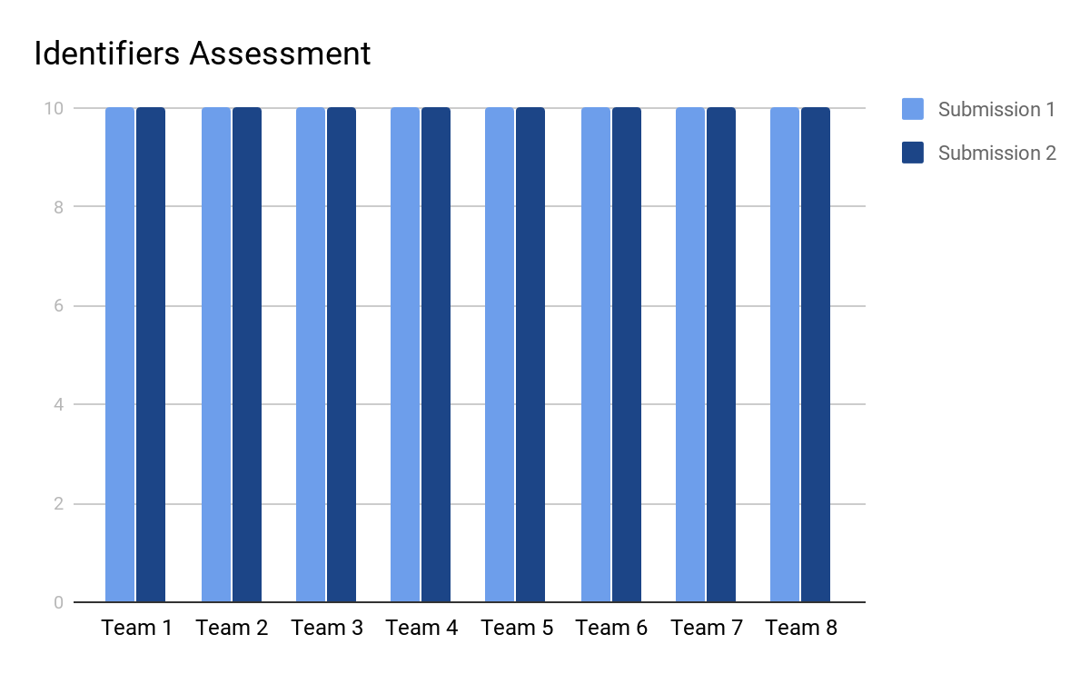

In addition to, we asked them to fill online survey we have created it to see if they are satisfied of this experiment and what is their opinion about our project, and the feedback was positive and encouraging.

Summary

In this part we have discussed how we tested our projects and what are the results of this testing and how the received feedbacks from the users helped us to maintain and fixing the bugs, In addition to we are showing the User Manual for Future Marker that shows the user how to use it as a student or instructor, Furthermore we have discussed our evaluation for the user experiments.

# Chapter 4 Discussion and Conclusion

**Main points**

* [give a brief abstract of your chapter here]

## Introduction

Here in this chapter we have reached the last phase of the project after we have finished the previous phases as we discussed in them the main problem that we are solving it and how we have solved it and what methodology we have followed, and the deliverables of the project, also we have discussed

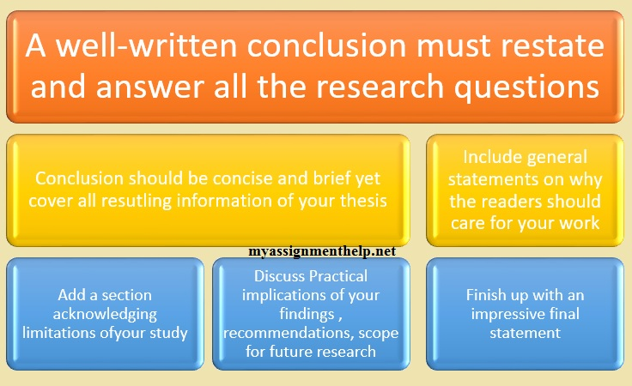

Figure 1

## Main Findings

### Why is this project important?

There is no doubt that the automation and artificial intelligence are making our life easier and saving our valuable time, all universities and schools today are willing to have an Learning management system not just for facilitating their work and deliver the material and lessons for the students easily, also it becomes necessary for them today to use it as they we have seen in the lockdown that we faced because of the epidemic of Coronavirus (COVID-19), so **Future Marker** allows the instructors to communicate with students and deliver the course materials for them in addition to providing them with and automation assessments system that automatically mark the programming assignments that submitted by the students and giving them a grading report, furthermore **Future Marker** provides online quiz system so the universities and schools can easily examine their students online from home.

### Practical Implementations

We will discuss who will use our application from the user perspective, we will be having two main users which are:

* Instructor
* Student

First the instructor, The instructor will be using the application because of its advantages that will help him innovate new way of learning and connecting with the his students, first of all he will be able to have social experience throw making posts which the student who enroll in his course or follow him can interact with, also he can create courses, upload material, assign grades, assignments and make quizzes, and with the integration of the auto marking in the system the students can get there grades immediately after upload his answers which saves afford and time.

Next the Student which will benefit from the platform which collect all the courses material, assignments, grades in one place which he can access from anywhere, and with the instant feedback on the assignments they will have a whole new experience because they can learn more from their mistakes from the detailed report of the assignment grading.

## Future Recommendation

Lorem ipsum dolor sit amet, consectetuer adipiscing elit.

## Conclusion Summary

Lorem ipsum dolor sit amet, consectetuer adipiscing elit.

# References

|  |  |
| --- | --- |
| [1] | D. Gooblar, “news,” 4 January 2017. [Online]. Available: https://chroniclevitae.com/news/1656-how-can-we-minimize-grade-challenges. |
| [2] | L. T. Culwin F, “ Plagiarism issues for higher education,” *Emerald Inshight,* pp. 36-41, 2001. |
| [3] | T. A. Khan, “buyer-blog/how-technology-improves-education,” 28 march 2019. [Online]. Available: https://www.trustradius.com/buyer-blog/how-technology-improves-education. |
| [4] | V. A. Shashank Srikant, “A System to Grade Computer Programming Skills using Machine Learning,” 2014. |
| [5] | HOLLINGSWORTH, “The morphology of intersexes in Drosophila subobscura,” *The Journal of experimental zoology,* vol. 143, 1960. |
| [6] | E. a. H. C. a. S. P. a. T. A. Foxley, “The CourseMaster Automated Assessment System - a next generation Ceilidh,” 2001. |
| [7] | N. G. R. B. Mike Joy, “The boss online submission and assessment system,” 2005. |
| [8] | S. S. Peter Brusilovsky, “Individualized exercises for self-assessment of programming knowledge: An evaluation of QuizPACK,” September 2005. |
| [9] | T. R. Tuukka Ahoniemi, “aloha title : a grading tool for semi-automatic assessment of mass programming courses,” February 2006. |
| [10] | O. L. A. N. W. C. Jacques Philippe Sauvé, “EasyAccept: a tool to easily create, run and drive development with automated acceptance tests,” May 2006. |
| [11] | T.-L. W. Fu Lee Wang, “Designing Programming Exercises with Computer Assisted Instruction,” August 2008. |
| [12] | H. Suleman, “Automatic marking with Sakai,” 2008. |
| [13] | M. A. P.-Q. Stephen H. Edwards, “Web-CAT: automatically grading programming assignments,” September 2008. |
| [14] | T. Verhoeff, “Programming Task Packages: Peach Exchange Format,” 2008. |
| [15] | J. C. M. E. F. B. Draylson Micael de Souza, “ProgTest: An environment for the submission and evaluation of programming assignments based on testing activities,” 2011. |
| [16] | S. a. A. V. Srikant, “A system to grade computer programming skills using machine learning,” 2014. |